Diana Liang

Fall 2019 Stats 500

9/14/19

**Homework #1: Teenage Gambling Survey Summary**

47 persons were surveyed to study teenage behavior involving gambling in Britain, as detailed in Ide-Smith & Lea (1988) Journal of Gambling Behavior. Each was asked about their sex, status, income, verbal score, and gambling expenditure. Below is a summary of the survey’s findings.

**Sex:**

summary(teengamb$sex)

## Male Female   
## 28 19

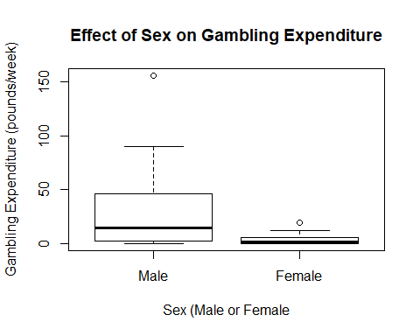

Males have a greater deviation in gambling expenditure compared to females, as the quartile range was wider and the whiskers longer for males, and they also have a greater gambling mean compared to that of the females.

**Status:**

summary(teengamb$status)

## Min. 1st Qu. Median Mean 3rd Qu. Max.   
## 18.00 28.00 43.00 45.23 61.50 75.00

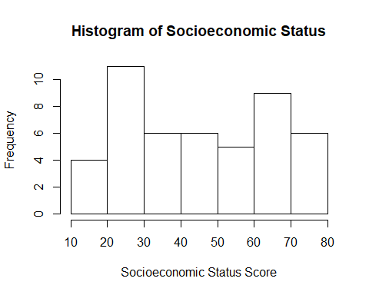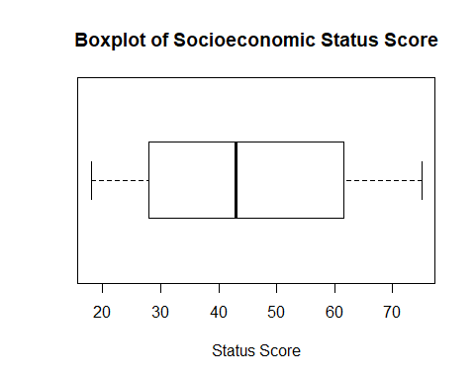

The mean score of 45.23 and median score of 43.00 are similar, suggesting a symmetric distribution of the socioeconomic status that is also shown in both the histogram and the boxplot.

**Income:**

summary(teengamb$income)

## Min. 1st Qu. Median Mean 3rd Qu. Max.   
## 0.600 2.000 3.250 4.642 6.210 15.000

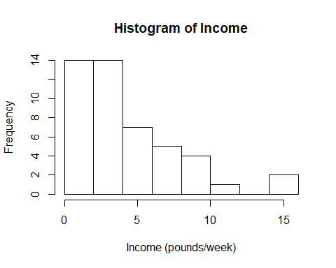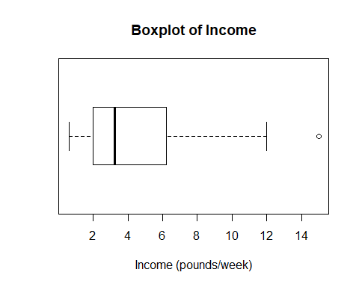

The income data has a mean of 4.642 pounds/week and a median of 3.250 pounds/week. The mean is greater than the median since, as the histogram and the boxplot show, that the data is skewed right, leading to a greater density of those with lower socioeconomic status.

**Verbal:**

summary(teengamb$verbal)

## Min. 1st Qu. Median Mean 3rd Qu. Max.   
## 1.00 6.00 7.00 6.66 8.00 10.00

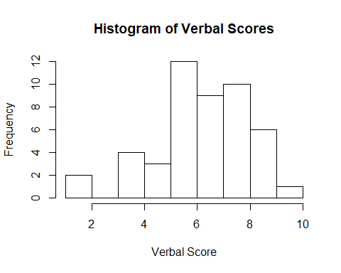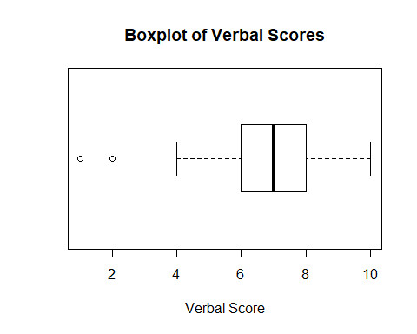

The verbal score data has 13 possible values (0-12). The histogram shows that only 8 of the possible values (2, 4, 5, 6, 7, 8, 9, and 10) were recorded. Of those, the boxplot suggests two outliers that are below the lower whisker bound of 4. The two outliers are #31 with a verbal score of 2 and #35 with a verbal score of 1.

**Gamble:**

summary(teengamb$gamble)

## Min. 1st Qu. Median Mean 3rd Qu. Max.   
## 0.0 1.1 6.0 19.3 19.4 156.0

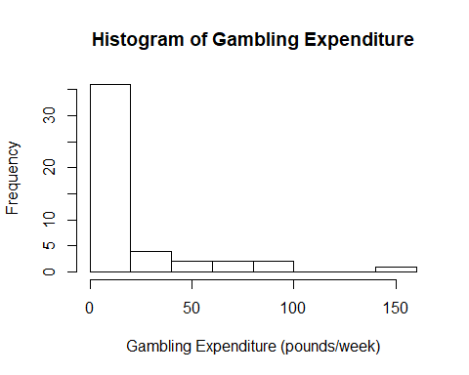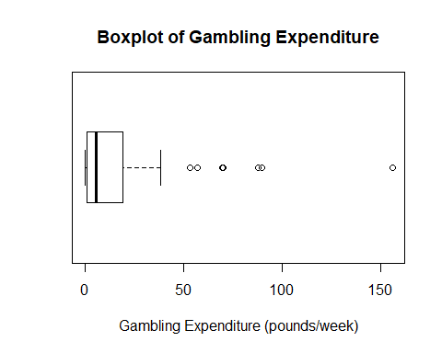

The mean of 19.3 pounds/week is greater than the median of 6.0 pounds/week, and both the histogram and boxplot suggest that the distribution of gambling expenditure is skewed right, meaning that a greater density of the surveyed had lower gamble expenditure. There are also many outliers suggested by the boxplot, as most of gambling expenditure was below 50 pounds/week with only a scattering of those above.